CLIENT PORTFOLIO MANAGEMENT SYSTEM
Final Project
For
IST659 – Database Admin Concepts & Management

By
Clark Thompson
A report submitted in partial fulfillment of the requirements for IST659
Submitted to
Susan Dischiave
On
April 28, 2009

Clark Thompson
Syracuse University School of Information Studies
Syracuse, NY 13224

Susan Dischiave
305 Hinds Hall
Syracuse University School of Information Studies
Syracuse, NY 13224

Dear Susan:

This report has been prepared as a response to your request for the Client Portfolio Management System project. The report outlines important system architecture and project management considerations. This includes a statement of the business problem the project is to solve, the project scope, and a detailed explanation of the solution. This includes the database model itself, documentation on user interfaces and reports, a data dictionary, system catalog, conclusion, lessons learned, and appendices.

The report is broken into 10 main sections. Section 1, Planning, contains a description of the business, the business problem (why the system is necessary), decisions that can’t be made, the project scope, and finally assumptions and constraints. Section 2, Analysis, contains an explanation of the methodology used, processes supported, key personnel to the project, how work will change with the new system, benefits of the new system, and management problems posed by these changes. Section 3, Design, contains a list of business rules and the database entity relationship diagram (ERD). Section 4, Implementation, contains explanations and screenshots of forms, reports, and queries. Section 5, Support Requirements, explains the system’s backup plan, data privacy/security requirements, etc. Section 6, Documentation, contains a data dictionary and a system catalog, which explains the purpose and content of the most important database objects. Section 7, Conclusion, provides a summary of recommendations for implementation. Section 8, Lessons Learned, provides suggestions gleaned from this project that can be applied to future database projects. Section 9, Sources, contains a list of books and articles cited in the report, in APA style. Finally, Section 10, Appendix, contains the field names and data types of all fields in each of the database’s 13 tables.

If you have any questions or concerns regarding the project or the report, please contact me by e-mail at cbthomps@syr.edu or by phone at 315-380-1105. I will be glad to answer any questions or provide any additional information regarding the project.

Sincerely,

Clark Thompson
Table of Contents
Executive Summary 1
1 Planning 3
1.1 Description of the Business 3
1.2 Business Problem 3
1.3 Decisions Not Made 3
1.4 Project Scope 3
1.5 Assumptions and Constraints 4
2 Analysis 4
2.1 Methodology 4
2.2 Processes Supported 5
2.3 Key Personnel 5
2.4 How Work Changes 5
2.5 Benefits 6
2.6 Management Problems 6
3 Design 6
3.1 Business Rules 7
3.2 Data Model 8
4 Implementation 9
4.1 Input Forms 10
4.2 Reports 16
4.3 Additional Database Objects 22
5 Support Requirements 23
6 Documentation 24
6.1 Data Dictionary 24
6.2 System Catalog 27
7 Conclusion 30
8 Lessons Learned 31
9 Sources 33
10 Appendix 34

List of figures

Figure 1 – Analyst Entry Form 11
Figure 2 – Client Entry Form 12
Figure 3 – Instrument Maintenance Form 13
Figure 4 - Portfolio Maintenance Form 14
Figure 5 - Portfolio Ownership Maintenance Form 15
Figure 6 - Transaction Entry Form 16
Figure 7 - Portfolio and Holdings Report 17
Figure 8 - Instrument and Market Signals Report 19
Figure 9 - Portfolios by Owners 20
Figure 10 - Portfolios By Analyst Report 21
Figure 11 - Transaction Report 22

Executive Summary
The Client Portfolio Management System project seeks to improve business processes at Thompson Investment Services by automating tasks such as client management, portfolio management, and instrument forecasting. By carefully analyzing current business practices it is clear that opportunities exist for reducing costs and increasing customer base (and thus revenue) through the use of a database management system (DBMS) solution. By consolidating company data in one place and linking in the necessary forms and reports, the Client Portfolio Management System has potential to increase employee efficiency and investment effectiveness.
Currently, Thompson Insurance uses a mix of flat files and spreadsheets to manage data. It is difficult and time-consuming to compare data from different business processes, such as client management and stock forecasting. In addition, the lack of an integrated solution means that portfolio analysts lack common data to use in forecasting. Thus there is a wide range in effectiveness between them, giving inconsistent experiences to different clients. An automated solution is needed to assist Thompson Insurance in forecasting returns, risks, and transaction costs, as well as determining appropriate portfolio management fees and analyst salaries and commissions. The project will follow the Systems Development Life Cycle methodology (SDLC) and the team will include the CIO, Financial Analysts, the Head of Human Resources, and the CEO. Work will change in that the processes will become more automated. This will reduce costs, allowing middle-income people to enter the customer base. Management problems may arise involving the lack of independence of decision-making among analysts now that decisions are more automated.
A set of 10 business rules was created to ensure requirements are understood prior to database design. Then, in order to store the data necessary to run the Client Portfolio Management System, a normalized database was created. This database contains 13 related tables. These tables are normalized to the 3rd form in order to remove redundant data. This reduces the amount of hard disk necessary to store data and prevents data inconsistencies that can happen if data is not normalized.
This project will be implemented through the use of tables, forms, queries, and reports. The tables will make use of primary and foreign keys to protect data integrity. Forms will be utilized for users to browse and input data. Queries will be used to show options on dropdowns on forms as well as to drive reports. Reports will be used to provide easy-to-read and printable views of aggregated data.
In addition to functional requirements, which state the services the system provides to users, one must also consider non-functional requirements. These requirements involve many technical aspects of the project, such as how the data is to be backed up and recovered, what policies should be in place regarding file retention, how database changes will be audited, how fraudulent activity will be monitored, and how user data security and privacy will be protected.
In order for business users and technical staff to understand the Client Portfolio Management System several types of documentation were created. A data dictionary was written to explain the purpose of each table, what its attributes are, and information on each attribute such as whether it is required (not null), the domain of the data (data range), default values for the attribute, whether it is a key, and any tables this attribute references as a foreign key. The data dictionary was written for 2 of the 13 tables, and should be expanded to all 13 tables as soon as resources permit. In addition, a system catalog was created. It includes not just tables, but other objects that pull information from tables, such as queries and views, and other objects that users interact with, such as forms and reports. It is helpful to create a system catalog to document the purpose of each object, expected data volumes, and links from this object to others in the system. This system catalog contains 8 objects, 2 each of the following 4 types of objects: tables, forms, queries, and reports.
In conclusion, the Client Portfolio Management System will provide many advantages in managing clients and making wise investment decisions. Though the current company IT infrastructure involves many unlinked flat files and spreadsheets, the new system will bring all the data needed for business processes into one system. This allows for many advantages. For one, data is stored in one place and is thus consistent. Second, queries can be written to easily join information from different tables, such as comparing client portfolio values to analyst compensation. Finally, information in a DBMS can be linked to a web application to allow clients to interact with their portfolios. This increases customer satisfaction, potentially increasing the client base.
While the system created for this project satisfies the functionality of a basic portfolio management system, many improvements would need to be made for it to actually function at a real corporation. For one, the system needs to be migrated to an enterprise DBMS that possess advanced security features. Due to the sensitive nature of the data it is important to ensure that clients each have a secure login and password and that when logged in they can only access information on their own portfolios. Second, a backup and recovery plans needs to be implemented. Data should be backed up to tape several times a day. Backup tapes should be sent to a secure remote location and encrypted in case of loss or theft. Finally, the database needs a historical aspect to comply with any disputes or government requests for records. Audit tables fed by triggers should maintain records of each update, delete, or insert to a table.
At the conclusion of any IS project it is important to reflect on lessons learned as a result of the efforts necessary to bring the system to completion. This allows one to learn from mistakes and to accomplish projects more effectively and efficiently in the future. The 5 lessons learned from the Client Portfolio Management System were that it is important to limit project scope, it is important to spend sufficient time on analysis, it is important to break projects into phases, it is important to present supporting documentation when implementing a project, and it is important to understand a system’s technical requirements in order to implement using the most appropriate technology solution.
The Client Portfolio Management System will provide an effective way of consolidating data and improving business practices. Through the use of a DBMS solution, manual task costs can be reduced, information accuracy can be improved, and income can grow through increased customer satisfaction and volume.

Planning

Description of the Business
This project is for the company Thompson Investment Services. Thompson Investment Services belongs to the Industry Category of Services and Industry Subcategory of Financial services. Regarding products and services, Thompson Investment Services manages investments for high-income individuals. Clients specify their growth goals and risk tolerance. Investment specialists suggest a portfolio of different financial products (stocks, bonds, currencies, mutual funds, etc.) to match their clients’ requirements. When it comes to decision-making, currently Thompson Investment Services conducts business operations using a combination of paper, text file, and spreadsheet records. Investment analysts read newspapers, trade journals, and financial web sites in order to research companies and determine their stock growth potential. Decisions are made individually by these analysts, using experience and personal instincts.

Business Problem
Thompson Investment Services currently has a business problem: the company suffers from a lack of integrated, up-to-date market data, which leads to inconsistent (and sometimes poor) decision-making among different financial analysts. Also, client contact information, client portfolio performance, and analyst salary and commissions (which are based on portfolio performance) are stored in separate spreadsheets, which requires manual integration work, and thus slows business processes.

Decisions Not Made
Without access to quality information, the following decisions cannot be made effectively:
- Which financial instruments (i.e. stocks, bonds) should be expected to yield maximum returns?
- What is the comparative risk of various financial instruments?
- What is the expected transaction cost for each financial instrument?
- How much should the company charge each client for its financial management services?
- Based on client portfolio performance, what should the compensation of the financial analyst staff be?

Project Scope
This project supports the business functionality of tracking clients, their portfolios, and holdings in each portfolio. It also tracks analysts, including which portfolios they manage and how much they are compensated for their management. The system tracks transactions to buy and sell instruments and tracks the market signal values that contribute to the expected return forecast for each instrument. Forms are used to add, delete, and modify clients, analysts, instruments, market signal values, portfolios, portfolio owners, and transactions. Reports, driven by queries, are used to show portfolio information (including holdings) for each client, ownership of each portfolio (including joint ownership), analyst manager salary and commission compared to portfolio values managed, details for each transaction (buying or selling instruments), and details about each instrument, including the market signal values that make up its expected return forecast.
One function that was considered, but not included, due to the necessity to keep the project scope small for this assignment, was the use of vendor feed tables. The data in the InstrumentMarketSignal table would normally be fed from a combination of vendor feeds. Each vendor feed would likely be loaded into a staging table specific to the data format of that vendor. Then, the vendor-supplied market signals would be combined using preprogrammed rules to calculate the data that is ultimately stored in the InstrumentMarketSignal table.
Another function that was outside the scope of this small assignment was the use of auditing controls. For simplicity, this was left out, but it would be an important aspect of a real financial system. For an actual system, one would create audit tables for each table in the database. These tables would have the same fields as the original tables, with the addition of fields to store change type (update/insert/delete), user name, and date/time of change. MS Access does not have triggers in the way that MS SQL Server and Oracle do. So, either the system would have to be implemented in an enterprise solution like SQL Server or Oracle, or one would have to write VBA code linked to each input form to fill the audit tables when the user made a data change through a form.
Another aspect that is important in this type of system, but is not included, is careful security controls. All system users would need a login name and password. In addition, through the use of database roles, users would be given permission to only the tables and rows they are allowed to view. Role-level security can be accomplished in certain DBMSs through the use of views.
A final aspect important to this system, but not implemented, is the backup and recovery plan. Since the database was created in MS Access, it is not possible to use advanced backup and recovery methods such as incremental backups. Thus in Access, given that the database size is limited, the best plan would probably would be to copy the entire database file to another file server and then to back up that file to tape.

Assumptions and Constraints
One assumption made during the development of this project is that in order for the system to support many features necessary for an enterprise system it would have to upgraded to a superior database platform to MS Access. While Access allows one to become familiar with many data modeling concepts, such as creating tables, assigning primary and foreign keys, and creating queries, it does not support advanced features needed for production systems, such as bulletproof authentication and authorization and triggers to audit data changes.
Another assumption made during the development of this project is that the system requires web-enabled forms in order for it to actually be accessible by users. In the database I used Access forms for data entry. However, for a system that needs to be available to users around the country it would be necessary to create a web front end, written in a language like PHP or ASP.net, that would use html forms to collect user data, save it to the database, and feed back information in the form of html reports.

Analysis

Methodology
In order to accomplish this project, the Systems Development Life Cycle (SDLC) will be used. This involves the following steps: (1) Planning. During planning, enterprise modeling will analyze how data is currently processed, determine business needs for improved processing, and document the need for better data management. Conceptual data modeling will identify how database technology can meet these needs and map out general business data requirements. (2) Analysis. During analysis, conceptual data modeling will continue, now becoming more specific as entities, attributes, and business rules are defined. (3) Database design. First, logical database design will determine the different ways the user will access and work with the system, including views, forms, transactions, and security restrictions. Physical database design follows, in which the database is created on disk and indexes, file groups, partitions, etc. are created. (4) Database Implementation. During implementation, stored procedures, views, and input/output processing are coded, users are trained, and the system is installed to production servers. (5) Database maintenance. During maintenance, bugs are fixed, enhancements are added, and performance is tuned for maximum efficiency (Hoffer, 2007).

Processes Supported
The new database system will support 4 important business processes: (1) return, risk, and transaction cost modeling, (2) transaction processing, (3) client management, and (4) human resource management. Return, risk, and transaction cost modeling involves using numeric data regarding price trends, analyst forecasts, company fundamentals, etc., predicting for different financial instruments the percentage return per time period, the relative risk, and the transaction cost to buy and sell these instruments. Transaction processing involves tracking all financial instrument purchases, including shares bought / sold, price, broker used, customer purchased for, etc. Client management involves maintenance of client contact information, investment preferences, holdings, and portfolio return history. Human resource management involves maintenance of employee contact information, salaries, and commissions earned.

Key Personnel
The key personnel critical to the Client Portfolio Management System are the CIO, Financial Analysts, the Head of Human Resources, and the CEO. The CIO is important because this is the largest information systems project to date undertaken by the company. Thus, the CIO must sign off on the business requirements, approve the system design, and assign his strongest staff members to the project. Financial Analysts are important because this group of system users know the nature of the financial data and how it should be processed, so their input is critical to the project. The Head of Human Resources is crucial to the project because this system will store employee information and automate salary and commission decisions. Thus, this executive must provide input as to how these functions should work. Finally, the CEO must provide project oversight. The CEO must ensure that the business process changes brought about by the new system are in line with the company’s strategic goals, as “top management is responsible for developing [the company’s] long-term strategic plans” (Williams, 2008, pg. 84).

How Work Changes
The consolidation of financial data into a central database will allow for automation of return forecasting. This was previously carried out individually and differently by each financial analyst. Instead of acting on intuition and hunches, financial analysts decide upon a common return model to use for all clients. Financial analysts will thus need to work as a team, instead of as competitive individuals. They must also become familiar with database concepts in order to best articulate which data should be stored, how it should be input, and how it should be reported on.

Benefits
The new database-driven system will be used to help the business make better decisions. The database centralizes all data into a set of normalized and related tables. This offers a number of benefits to the old way of doing business, which used a number of flat files and Excel spreadsheets. In the past, data could not be related between different data stores. There was no automated method of ensuring that a customer existed in one spreadsheet before being linked to a portfolio managed by an analyst in another spreadsheet. This led to data errors and thus incorrect calculations. In addition, many administrative staff were required to compare and aggregate data manually between different files. Instead, this can now be accomplished through simple queries, saving the company money.
The company will be able to make better decisions regarding which assets to invest in. The database can aggregate data and apply models to calculate expected returns, risks, and transaction costs. The data can help management make determinations regarding client portfolio fees and compensation for the analysts managing each portfolio. Using consistent and high-quality data the new database will provide a better basis for decision-making.

Management Problems
A number of management problems may be introduced by this project. Staffing requirements will change across the company, which presents a major challenge for Human Resources. Financial analysts must be more tech-savvy and more team-oriented. The CIO must increase his technology staff to include database administrators, system analysts, and programmers. Customer management changes will arise as well. As one model now predicts returns for all clients, each client does not require as much individual attention. Thus the customer base will increase from small numbers of high-net worth clients to many middle-income customers. Customer service staff must learn to serve a new type of client, which could lead to dissatisfaction and increased turnover. Business process reengineering is disruptive to employees and its effects must be carefully analyzed (Piccoli, 2008).

Design
When designing an information system, whether or not it is a database system, it is important to specify business rules in advance. These business rules should be written in language understandable to non-technical company employees. This allows users to write business rules and to approve or correct the business rules suggested by the technology staff. These business rules should not be specific to any platform or programming language, as appropriate technology decisions can only be made after the business rules are known. This section spells out 10 of the business rules for the Client Portfolio Management System. Further, it explains how each of these business rules would be implemented in the database.
In order to store the data necessary to run the Client Portfolio Management System, a normalized database was created. This database contains 13 related tables. These tables are normalized to the 3rd form in order to remove redundant data. This reduces the amount of hard disk necessary and prevents data inconsistencies that can happen if data is not normalized.

Business Rules
 | Business Rule | Implementation
1 | Each Instrument has an Instrument Type. | 1 to Many relationship between InstrumentType table and Instrument table
2 | Many Instruments belong to each Portfolio. | PortfolioInstrument is a bridge table between the Portfolio table and the Instrument table.
3 | A Portfolio is owned by one or more Clients. | PortfolioOwner is a bridge table between the Portfolio table, Client table, and ClientOwnerType table.
4 | A Transaction is the purchase or sale of a given number of shares of an Instrument. | 1 to Many relationship between Instrument table and Transaction table.
5 | A Transaction is conducted for one Portfolio. | 1 to Many relationship between Portfolio table and Transaction table.
6 | A Portfolio is managed by an Analyst. | 1 to Many relationship between Analyst table and Portfolio table.
7 | The return potential of an Instrument is predicted by summing the weighted values of Market Signals for that Instrument. | InstrumentMarketSignal is a bridge table between the Instrument table and the MarketSignal table. Summing (InstrumentMarketSignal.imsValue * MarketSignal.marketSignalWeight) for all the rows in InstrumentMarketSignal for a given InstrumentID gives the return potential of the Instrument.
8 | A Portfolio’s value is the sum of the prices of the Instruments in that Portfolio. | The portfolioValue column in the Portfolio table is a calculated field summing the instrumentPrice field in the Instrument table for all Instruments belonging to the Portfolio (determined by the PortfolioInstrument table). The calculated field is stored so that retrieval is faster.
9 | A Transaction is first submitted and then completed. | A check constraint on the Transaction table requires that (transactionCompleteDateTime > transactionSubmitDateTime) OR transactionCompleteDateTime IS NULL.
10 | A Transaction can be open, in progress, canceled, or completed. | A check constraint on the Transaction table requires that (transactionStatusFlag IN (‘OP’,’IP’,’CA’,’CO’))

Data Model
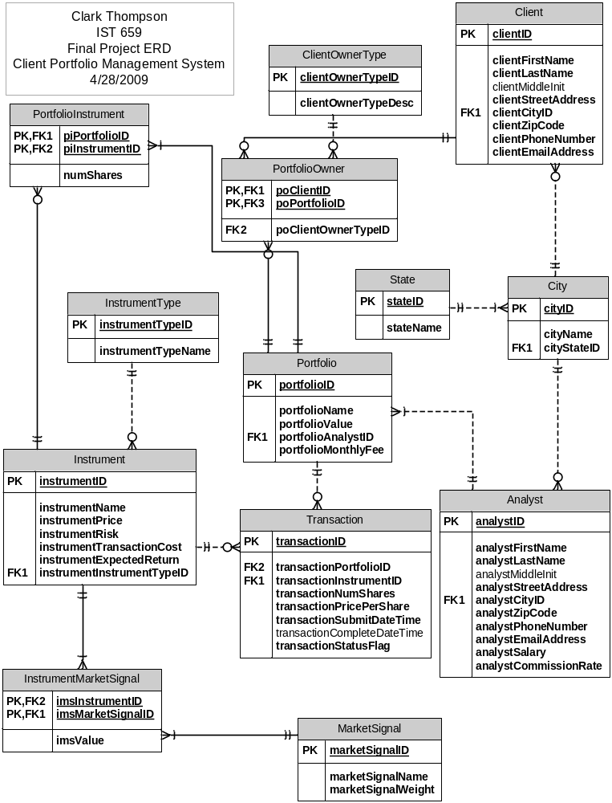

Implementation
This project will be implemented through the use of tables, forms, queries, and reports. The tables will make use of primary and foreign keys to protect data integrity. Forms will be utilized for users to browse and input data. Queries will be used to show options on dropdowns on forms as well as to drive reports. Reports will be used to provide easy-to-read and printable views of aggregated data.

Input Forms
The following shows the forms used to browse, insert, update, and delete data in the Client Portfolio Management System.

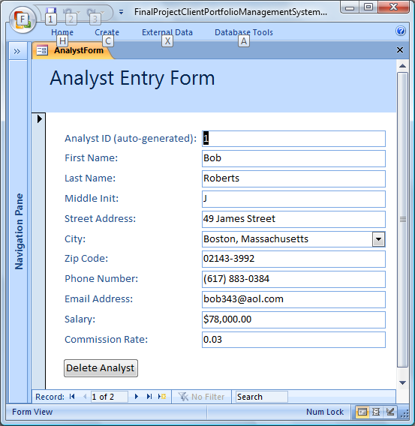
Figure 1 – Analyst Entry Form
The Analyst Entry Form allows HR administrative personnel to maintain information on the company’s Financial Analysts. Contact information is maintained, as well as the salary and commission rate for each analyst. It is useful to store compensation information in the database, because one can then write reports to compare the compensation of each analyst to the value of the portfolios he or she manages to see if his or her salary should be adjusted based on performance.

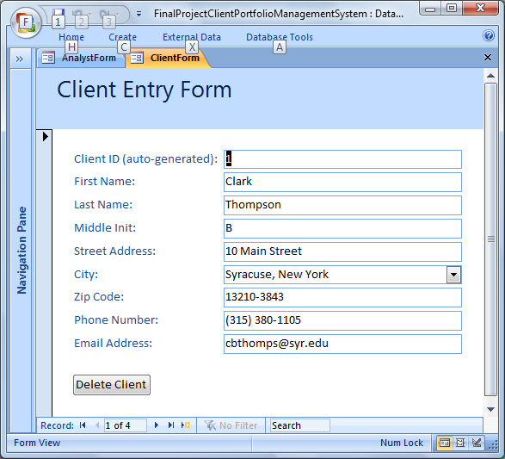
Figure 2 – Client Entry Form
This Client Entry Form allows HR administrative personnel, as well as customers, to keep customer contact information up to date. It is important to keep accurate contact information for each client because clients are sent portfolio statements either by e-mail or by postal mail. Phone numbers are important for contacting clients in case of a suspected breach in their accounts.

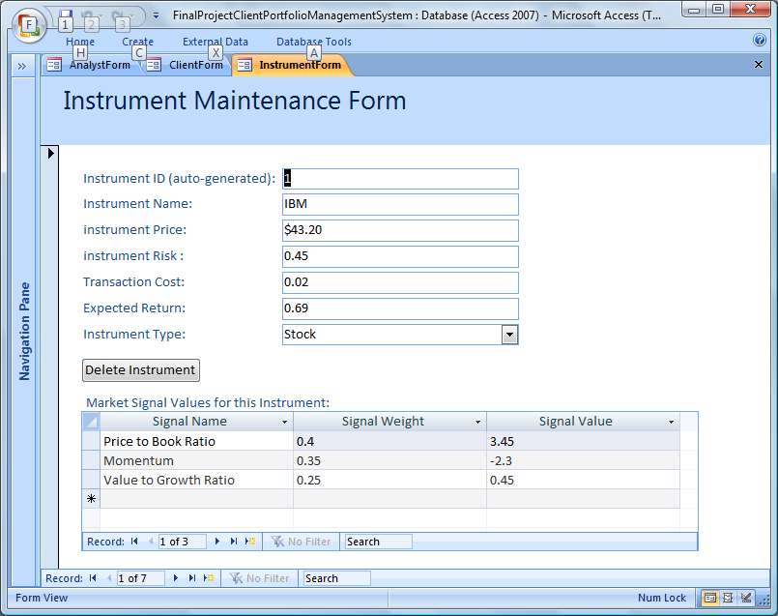
Figure 3 – Instrument Maintenance Form
The Instrument Maintenance Form is used by Analysts to add instruments to the universe of available instruments that may be added to client portfolios. Each instrument has certain characteristics, such as its price, risk, transaction cost, and expected return. The subform shows the market signal values that contribute to the Expected Return. If the sum of Signal Weights * Signal Values are calculated it will sum to the Expected Return.
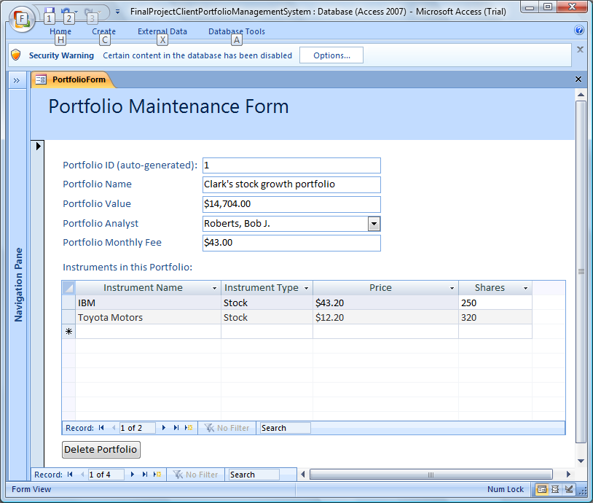
Figure 4 - Portfolio Maintenance Form
The Portfolio Maintenance Form is used by clients and analyst staff to maintain client portfolios. The analysts talk to clients to understand their investment goals and then create a portfolio with a name of the client’s choice. Then they use the subform to add instruments to the portfolio. The Portfolio Value shown is equal to the sum of the Price * Shares for all of the instruments in the Portfolio. The clients may choose to buy and sell stocks, which will affect the instruments listed in their portfolio. They may choose to bypass the analyst and instead add or remove instruments from their portfolio.
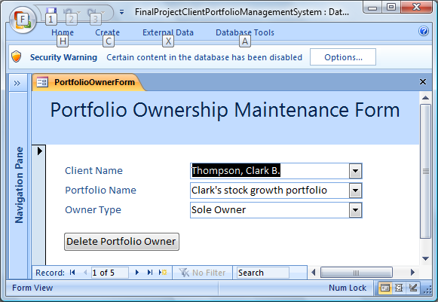
Figure 5 - Portfolio Ownership Maintenance Form
The Portfolio Ownership Maintenance Form is used by analysts to maintain the relationship of clients to Portfolios. A Portfolio can have a sole owner or it can multiple joint owners.
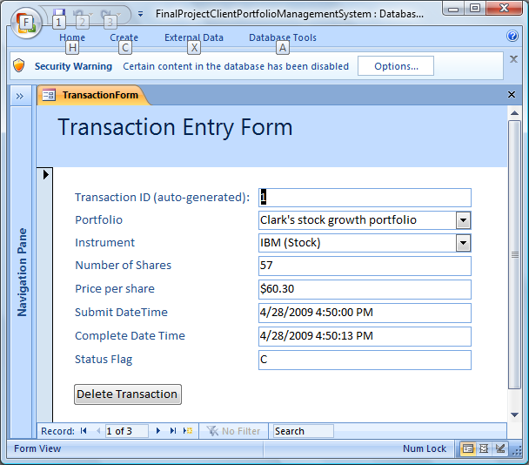
Figure 6 - Transaction Entry Form

The Transaction Entry Form is used by analysts to enter transactions to buy and sell instruments. A modified version of the form would be available via the application’s web site in which clients would be able to conduct buy and sell transactions. In this case, they could add new transactions or cancel pending transactions, but they could not modify closed transactions.

Reports
The following shows the reports used to view individual and aggregate data in the Client Portfolio Management System:

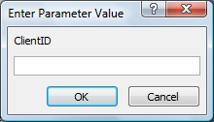
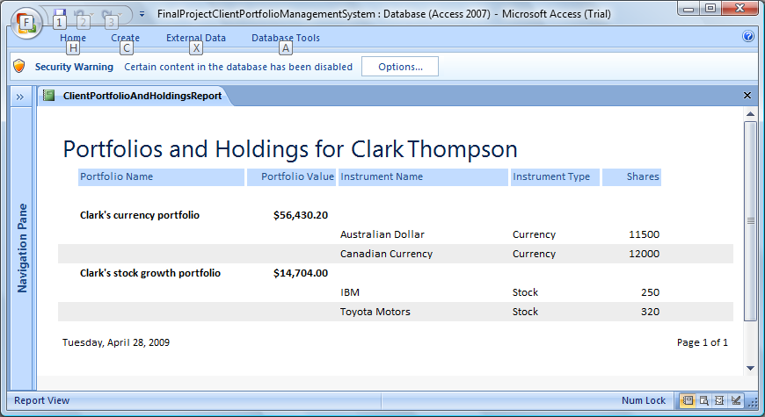
Figure 7 - Portfolio and Holdings Report
The Portfolio and Holdings Report is used by clients and analysts to view all the portfolios and holdings for a given client. Notice that the first screen shot shows a screen that prompts the user to enter a Client ID. This would only appear in the analyst version of the report, so that he or she could view a report on a given client’s portfolio. For the client, the report would already know his or her identity based on his/her login, so he/she would not be prompted for a Client ID. The report shows each portfolio name and value, and inside each portfolio shows the instruments that belong to the portfolio.
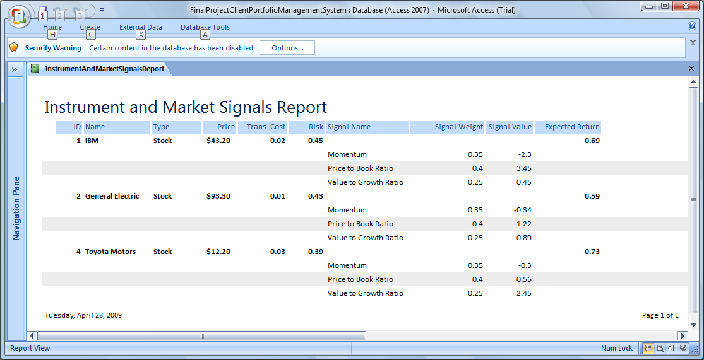
Figure 8 - Instrument and Market Signals Report
The Instrument and Market Signals Report provides information on each instrument, including its name, type (stock, currency, etc), its price, transaction cost, and risk. It also provides details of the different market signal values that add up to the instrument’s Expected Return (summing Signal Weight * Signal Value gives this number). This report is only available to analysts. It is not available to clients because the details of signals and weights used to predict returns is proprietary information. The clients can access a different version of this report that only gives the total Expected Return without the component signal values.
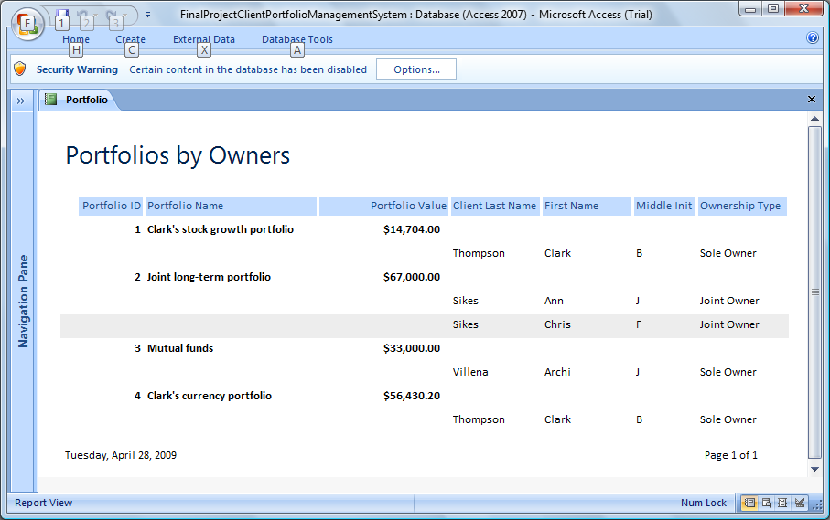
Figure 9 - Portfolios by Owners
The Portfolios by Owners Report is used by marketing staff to keep track of client portfolio values. They scan the list of clients to gauge which clients have the highest portfolio values and therefore deserve more individual attention. They also seek out clients with only 1 portfolio to look for opportunities to encourage clients to open additional portfolios to take advantage of different mixes of investments.
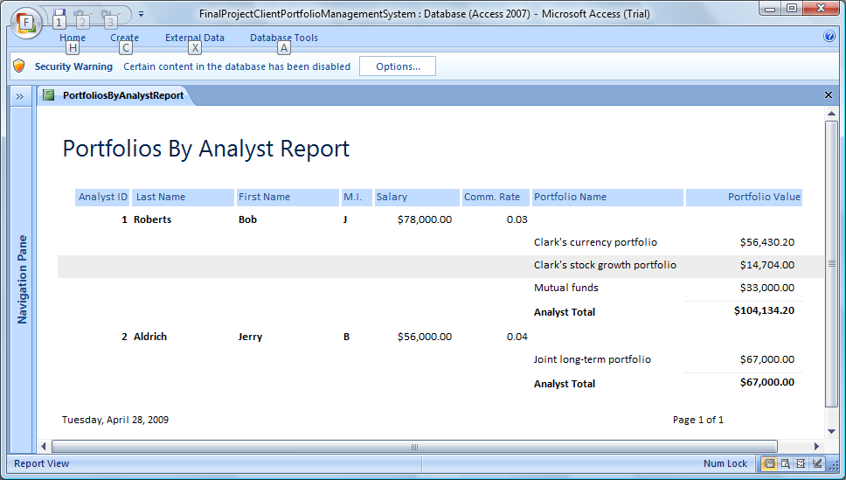
Figure 10 - Portfolios By Analyst Report
The Portfolios By Analyst Report is used by Human Resources to determine proper compensation for each analyst. The report shows the salary and commission rate of each analyst compared to the value of the portfolios that they manage. If an analyst is managing a high total amount but is being compensated lower than other analysts HR might choose to increase the analyst’s salary or commission rate.

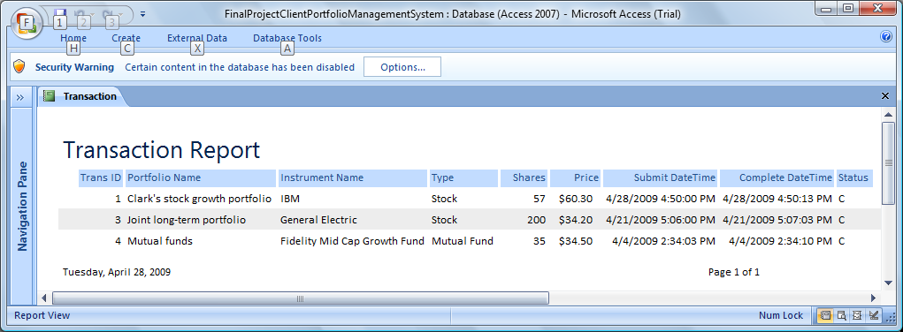
Figure 11 - Transaction Report
The Transaction Report is used by Compliance staff to monitor client portfolios for unusual, and potentially fraudulent, activity. If a portfolio with few transactions in the past suddenly has a great number of transactions it might indicate a breach in an account and access to the account might be frozen and the client contacted. The report is also useful for reporting to government agencies such as the Securities and Exchange Commission when investigating allegations of trading violations such as insider trading.

Additional Database Objects
The following is a list of important database queries in the Client Portfolio Management Database:

The AnalystQuery returns a list of Analyst IDs and full names. This drives the Analyst drop down box on the Portfolio Maintenance Form:
SELECT Analyst.[analystID], Analyst.analystLastName+', '+Analyst.analystFirstName+' '+Analyst.analystMiddleInit+'.' AS analystName
FROM Analyst;

The CityAndStateQuery returns a list of City IDs and a concatenation of City Name and State Name. It is used on City dropdowns on the Client Entry Form and the Analyst Entry Form:
SELECT CityID, CityName+', '+StateName AS CityAndState
FROM City, State
WHERE (((City.[cityStateID])=[StateID]))
ORDER BY cityName, stateName;

The ClientPortfolioAndHoldingsQuery returns a list of all portfolios for a given client and the holdings in that portfolio. It is used to drive the Portfolio and Holdings report. Notice the ClientID parameter:
PARAMETERS ClientID Long;
SELECT Portfolio.portfolioName, Portfolio.portfolioValue, InstrumentType.instrumentTypeName, PortfolioInstrument.numShares, Client.clientID, Client.clientLastName, Client.clientFirstName, Client.clientMiddleInit, Instrument.instrumentName
FROM (Portfolio INNER JOIN (InstrumentType INNER JOIN (Instrument INNER JOIN PortfolioInstrument ON Instrument.instrumentID=PortfolioInstrument.piInstrumentID) ON InstrumentType.instrumentTypeID=Instrument.instrumentInstrumentTypeID) ON Portfolio.portfolioID=PortfolioInstrument.piPortfolioID) INNER JOIN (Client INNER JOIN PortfolioOwner ON Client.clientID=PortfolioOwner.poClientID) ON Portfolio.portfolioID=PortfolioOwner.poPortfolioID
WHERE (((Client.clientID)=[ClientID]));

The ClientQuery returns a list of Client IDs and client full names. It is used on the Portfolio Ownership Maintenance Form:
SELECT clientID, clientLastName+', '+clientFirstName+' '+clientMiddleInit+'.' AS clientName
FROM Client;

The InstrumentAndMarketSignalsQuery returns a list of all instruments, information about each instrument, and the market signal values that apply to that instrument. It is used to drive the Instrument and Market Signals Report:
SELECT Instrument.instrumentID, Instrument.instrumentName, InstrumentType.instrumentTypeName, Instrument.instrumentPrice, Instrument.instrumentRisk, Instrument.instrumentTransactionCost, Instrument.instrumentExpectedReturn, MarketSignal.marketSignalName, MarketSignal.marketSignalWeight, InstrumentMarketSignal.imsValue
FROM MarketSignal INNER JOIN (InstrumentType INNER JOIN (Instrument INNER JOIN InstrumentMarketSignal ON Instrument.instrumentID = InstrumentMarketSignal.imsInstrumentID) ON InstrumentType.instrumentTypeID = Instrument.instrumentInstrumentTypeID) ON MarketSignal.marketSignalID = InstrumentMarketSignal.imsMarketSignalID;

The PortfolioOwnerQuery returns a list of all portfolios, the names of the portfolios, who the owner or owners are of each, and which type of ownership each person has. It is used to drive the Portfolios by Owners Report:
SELECT Portfolio.portfolioID, Portfolio.portfolioName, Portfolio.portfolioValue, ClientOwnerType.clientOwnerTypeDesc, Client.clientFirstName, Client.clientLastName, Client.clientMiddleInit
FROM Client INNER JOIN (Portfolio INNER JOIN (ClientOwnerType INNER JOIN PortfolioOwner ON ClientOwnerType.clientOwnerTypeID=PortfolioOwner.poClientOwnerTypeID) ON Portfolio.portfolioID=PortfolioOwner.poPortfolioID) ON Client.clientID=PortfolioOwner.poClientID;

The PortfoliosByAnalystQuery returns information on all the portfolios and who is the analyst for each portfolio. It is used by the Portfolios By Analysts Report:
SELECT Analyst.analystID, Analyst.analystLastName, Analyst.analystFirstName, Analyst.analystMiddleInit, Analyst.analystSalary, Analyst.analystCommissionRate, Portfolio.portfolioName, Portfolio.portfolioValue
FROM Analyst INNER JOIN Portfolio ON Analyst.analystID=Portfolio.portfolioAnalystID;

The TransactionQuery shows each transaction from the Transaction table and joins to the Portfolio, Instrument, and InstrumentType tables to get the portfolio name, instrument name, and instrument type name for each transaction. It is used in the Transaction Report:
SELECT Transaction.transactionID, Portfolio.portfolioName, Instrument.instrumentName, InstrumentType.instrumentTypeName, Transaction.transactionNumShares, Transaction.transactionPricePerShare, Transaction.transactionSubmitDateTime, Transaction.transactionCompleteDateTime, Transaction.transactionStatusFlag
FROM Portfolio INNER JOIN (InstrumentType INNER JOIN (Instrument INNER JOIN [Transaction] ON Instrument.instrumentID=Transaction.transactionInstrumentID) ON InstrumentType.instrumentTypeID=Instrument.instrumentInstrumentTypeID) ON Portfolio.portfolioID=Transaction.transactionPortfolioID;

Support Requirements
In addition to functional requirements, which state the services the system provides to users, one must also consider non-functional requirements. These requirements involve many technical aspects of the project, such as how the data is to be backed up and recovered, what policies should be in place regarding file retention, how database changes will be audited, how fraudulent activity will be monitored, and how user data security and privacy will be protected.
The following assumes that the Microsoft Access version of the database I created is upgraded to a more robust and feature-rich DBMS, such as SQL Server or Oracle, prior to implementation:
As the Client Portfolio Management database contains financial data, it is essential that data be backed up in order to recover from a hardware failure or deliberate hack. Four daily full database backups will be taken, each 6 hours apart. In addition, hourly differential backups will be taken as well. Each backup will be written both to tape and to a secure network drive. The network drive backup copies will be overwritten each day, and serve as the quickest possible way to restore from a backup. The backup tape storage plan will utilize a vendor specializing in data protection, who will store the tapes in several off-site locations. Daily backups will be retained for the prior 30 days, quarterly backups will suffice for the past year, and annual backups will be retained for the last 5 years. Due to the financial nature of the data, is it important to have this long history, so that potential securities violations can be investigation. The backup tapes will be encrypted prior to release to the data protection vendor to ensure no compromises are made in data privacy if tapes are lost or stolen.
In addition to an aggressive backup plan, the database will incorporate auditing via triggers. Though not shown on the data model, each table should have a corresponding audit table, which contains a historical record of all inserts, deletes, and updates to the table. No database user is allowed to directly write to the audit tables, ensuring their integrity. Reports can then be written to help Compliance staff review data changes via the audit table records.
Fraud detection will be implemented through careful monitoring of client portfolios by compliance staff. If a portfolio has unusual activity, the client will be contacted to ensure his or her account has not been compromised. For example, if a client who for several years has kept money in one mutual fund suddenly sells it and buys a number of high-risk stocks this would tip off compliance staff that a breach may have occurred.
Security and privacy will be maintained through close control of database security policies. Users will each have a user name and a password that meets certain complexity requirements. Users will only be able to access their data, through the use of role-level security. Analyst users will only be able to access the portfolio details of their own clients. Users with direct database access will only be able to browse data through views, in order to control the records they see. Only high-level company managers will be able to view all the data in the database.

Documentation
This section contains the data dictionary and system catalog for the Client Portfolio Management System.

Data Dictionary
The data dictionary contains the information about the attributes and keys of a given entity. For each attribute is listed the attribute name, description, type/size, format, whether it is required (not null), the domain of the data (data range), default values for the attribute, whether it is a key, and any tables this attribute references as a foreign key. The data dictionary is shown for 2 of the 13 entities in the database.

Table Name: Analyst

Table Description: The Analyst table is used to store contact and compensation information for each analyst.

Name | Description | Type/Size | Format | Req’d | Domain | Default/  Derived | Key | Ref.  Table
analystID | Analyst auto-assigned ID | Long Integer |  | Y |  |  | PK
analystFirstName | Analyst first name | Text (20) |  | Y
analystLastName | Analyst last name | Text (20) |  | Y
analystMiddleInit | Analyst middle initial | Text (1) |  | N
analystStreetAddress | Analyst street address | Text (50) |  | Y
analystCityID | Analyst city of residence | Long Integer |  | Y |  |  | FK | City
analystZipCode | Analyst zip code | Text (9) | 99999-9999 | Y | Numeric only
analystPhoneNumber | Analyst phone number | Text (10) | (999) 999-9999 | Y
analystEmailAddress | Analyst e-mail address | Text (50) |  | Y
analystSalary | Yearly Salary of analyst | Currency | $999,999,999.99 | Y | Positive numeric
analystCommissionRate | Decimal annual percentage analyst is paid from total funds under his/her management | Double | 0.99 | Y | > 0 and < 1

Table Name: Instrument

Table Description: The Instrument table is used to store information about each investment instrument (its name, type, price, risk, transaction cost, expected return, etc.)

Name | Description | Type/Size | Format | Req’d | Domain | Default/  Derived | Key | Ref.  Table
instrumentID | Instrument auto-assigned ID | Long Integer |  | Y |  |  | PK
instrumentName | Common name of the instrument (IBM, Fidelity Growth fund, etc) | Text (30) |  | Y
instrumentPrice | Most recent trading price of instrument | Currency | $9,999.99 | Y | > 0
instrumentRisk | The measures how volatile the instrument’s price swings are) | Number | 99.99 | Y | > -100 and < 100
instrumentTransactionCost | The trading fee required to buy and sell this instrument | Number | 99.99 | Y | > -100 and < 100
instrumentExpectedReturn | The percentage the price of this instrument is expected to increase in 1 month | Number | 99.99 | Y
instrumentInstrumentTypeID | Type of instrument (stock, mutual fund, etc) | Long Integer |  | Y |  |  | FK | InstrumentType

System Catalog
A system catalog is a compilation of information about objects created by users in a database. It includes not just tables, but other objects that pull information from tables, such as queries and views, and other objects that users interact with, such as forms and reports. It is helpful to create a system catalog to document the purpose of each object, expected data volumes, and links from this object to others in the system. This system catalog contains 8 objects, 2 each of the following 4 types of objects: tables, forms, queries, and reports.

Object Name: Client

Object Type: Table

Description: The Client table is used to store contact information for each client.

Object
Description:

Source: Client Entry Form.
Destination: The Client table will be used in all queries that retrieve client information, such as names and contact information.
There will be:
-- One record per client.
-- Growth of 1000 rows per year.
-- All records will remain on file even if the client’s account is inactive (for auditing reasons).
-- A client may access only his own information. An analyst may only access client information that is linked to portfolios that that analyst manages. An executive user or compliance user may access information on any client.
-- Related tables include:
        - City
        - PortfolioOwner

Object name: Instrument

Object Type: Table

Description: The Instrument table is used to store information about each investment instrument (its name, type, price, risk, transaction cost, expected return, etc.)

Object
Description:

Source: Instrument Maintenance Entry Form.
Destination: The Instrument table will be used in all queries that retrieve information about instruments, such as instrument types, prices, and expected returns.
There will be:
-- One record per instrument.
-- Growth of approximately 500 rows per year.
-- All records will remain on file even if an instrument is inactive (for auditing reasons).
-- All users (clients, analysts, compliance, executives) may access information about each instrument (the exception is the related InstrumentMarketSignals table, which clients may not access, due to its proprietary forecasting component information).
-- Related tables include:
        - InstrumentType
        - PortfolioInstrument
        - Transaction
        - InstrumentMarketSignal

Object name: AnalystForm

Object Type: Form

Description: The AnalystForm form maintains a list of portfolio analysts.

Detailed Description:

Source: Analyst Table, CityAndStateQuery
Destination: Analyst Table.

The AnalystForm is used to maintain information about the portfolio analysts. The contact information for each analyst is stored, as well as the salary and commission rate of each. Due to the sensitive nature of the data, only HR and executives may use this form.

Volume: 10 analysts added per year, 20 updates to existing analysts.
Frequency: when analysts are added, removed or altered.

Object name: PortfolioForm

Object Type: Form

Description: The PortfolioForm form is used to maintain information about each portfolio.

Detailed Description:

Source: Portfolio Table, AnalystQuery, PortfolioInstrumentSubform
Destination: Portfolio Table, PortfolioInstrument Table.

The PortfolioForm is used to maintain each client’s portfolio. This includes the portfolio name, present value, and analyst managing the portfolio. At the bottom of the form is the PortfolioInstrumentSubform, which shows all instruments that are part of the selected Portfolio. Clients may maintain their portfolio, including adding instruments to it. Analysts may maintain only the portfolios they manage.

Volume: 2000 portfolios added per year, 20,000 updates to existing portfolios per year, including adding or removing instruments.
Frequency: when portfolios are added, removed or altered.

Object name: ClientPortfolioAndHoldingsQuery

Object Type: Query

Description: This query returns a list of all portfolios for a given client and the holdings in that portfolio. It is used to drive the Portfolio and Holdings report. It has a parameter, ClientID, that determines which client to show portfolio information for.

Detailed
Description: Source: Portfolio Table, InstrumentType Table, Instrument Table, PortfolioInstrument Table.
Destination: ClientPortfolioAndHoldingsReport.

Object name: PortfoliosByAnalystQuery
Object Type: Query

Description: This query returns information on all the portfolios and who is the analyst for each portfolio.

Detailed
Description: Source: Analyst Table, Portfolio Table
Destination: PortfoliosByAnalystReport

Object name: ClientPortfolioAndHoldingsReport

Object Type: Report

Description: The Portfolio and Holdings Report is used by clients and analysts to view all the portfolios and holdings for a given client.

Detailed Description: Source: ClientPortfolioAndHoldingsQuery
Destination: Clients and Analysts.

When Clients run this report they are only shown their own portfolio information and holdings. The Analysts may choose to see portfolio information for any portfolio that they manage.

Object name: PortfoliosByAnalystReport

Object Type: Report

Description: The PortfoliosByAnalystReport shows the salary and commission for each analyst, and the name and value of each portfolio that each analyst manages.

Detailed Description: Source: PortfoliosByAnalystQuery
Destination: HR users.

The PortfoliosByAnalystReport is used by Human Resources to determine proper compensation for each analyst. The report shows the salary and commission rate of each analyst compared to the value of the portfolios that they manage. If an analyst is managing a high total amount but is being compensated lower than other analysts HR might choose to increase the analyst’s salary or commission rate.

Conclusion
In conclusion, the Client Portfolio Management System will provide many advantages in managing clients and making wise investment decisions. Though the current company IT infrastructure involves many unlinked flat files and spreadsheets, the new system will bring all the data needed for business processes into one system. This allows for many advantages. For one, data is stored in one place and is thus consistent. Second, queries can be written to easily join information from different tables, such as comparing client portfolio values to analyst compensation. Finally, information in a DBMS can be linked to a web application to allow clients to interact with their portfolios. This increases customer satisfaction, potentially increasing the client base.
While the system created for this project satisfies the functionality of a basic portfolio management system, many improvements would need to be made for it to actually function at a real corporation. For one, the system needs to be migrated to an enterprise DBMS that possess advanced security features. Due to the sensitive nature of the data it is important to ensure that clients each have a secure login and password and that when logged in they can only access information on their own portfolios. Second, a backup and recovery plans needs to be implemented. Data should be backed up to tape several times a day. Backup tapes should be sent to a secure remote location and encrypted in case of loss or theft. Finally, the database needs a historical aspect to comply with any disputes or government requests for records. Audit tables fed by triggers should maintain records of each update, delete, or insert to a table.

Lessons Learned
At the conclusion of any IS project it is important to reflect on lessons learned as a result of the efforts necessary to bring the system to completion. This allows one to learn from mistakes and to accomplish projects more effectively and efficiently in the future. The 5 lessons learned from the Client Portfolio Management System were:

- It is important to limit project scope. A project should accomplish the most important business functions and leave less-critical functions for possible later enhancements. Since I have experience with financial management systems I initially hoped to build a system to accomplish many functions outside of what I ultimately included in my database. However, as I began to plan tables to accomplish such features as vendor data file loading and transaction cost modeling I began to realize I would need many dozen tables. Therefore, I had to limit the scope of the database to include only the most critical functions of tracking clients, analysts, portfolios, instruments, transactions, and market signals. In order to effectively accomplish these functions in the short time frame of this class project I had to leave off extra functionality that was not critical.

- It is important to spend as much time as possible analyzing a business problem prior to actually beginning design and coding. In past projects in my career I have generally jumped into creating the data model before writing any business rules or other documentation. Then, as I began to actually code the forms and reports I would realize with each new form or report that the data model did not support the information needed for these objects. So I’d have to change the data model. Then, after those forms are reports were complete and I started to code the next round of objects, I would find another shortcoming in the data model and have to change it again, and also change code in the earlier round of forms and reports to work with the new data model. In this project, I was required to create a business analysis report prior to data model design and coding. This forced me to think carefully about the business problem and which business functions I would support. When the time came to code reports and forms I found I actually did not have to change the data model at all. Thus, an important lesson is that effort put into analysis saves one great amounts of time during implementation by reducing the amount of rework necessary.

- It is important to have project phases in which progressive deliverables are due. This project required 3 deliverables: (1) an analysis report, (2) a design report, and (3) the final project. Intermediate deliverables allow the business customer the ability to either accept or suggest improvement to the project before it continues to the next phase. This ensures that a project running for 6 months or 1 year does not end in implementation of a system that is completely different from what the business users need. If the project manager can create an analysis report and pass it to business users for approval this ensures that all are in agreement on the goals of the project. Also, intermediate deliverables ensure that progress is actually being made on the project. If, for example, the business sponsor sees that the IT staff has spent 3 months on project design without reaching any conclusions he or she may realize the project is beyond the ability of the IT staff to accomplish. The business sponsor may then terminate the project and save the money that would have been spent allowing the IT staff to struggle another 6 months before admitting defeat.

- It is important to present not just the completed system at the end of a project, but the documentation for the system as well. In past projects in my career the rush to implement the system usually resulted in the system being installed with almost no documentation and almost no user training. However, this project demonstrated the importance of presenting a final report at the same time as the competed system itself. For one, the report documents the system so that other IT staff can support it. Second, the report gives a business-level overview on the project so that all involved understand the reason the project is being installed. Finally, the report offers a reflection that includes lessons learned, so that mistakes made on this project can be avoided in future projects. For all these reasons, a final project report is important after a project implementation.

- It is important to understand the technical requirements of a system before beginning to implement the system using a particular technology. For the Client Portfolio Management System I chose to implement in MS Access. I did this because Access is an easy-to-use DBMS package that integrates all components of simple projects, such as tables, forms, queries, and reports. Access seemed a great choice until the end of the project, when I realized that it would not suffice for the security, auditing, and backup/recovery requirements of a financial management system. Fortunately, this project did not require actually implementing these features. It is important to note the limitations of MS Access, so that in future projects intended for actual use one does not handicap oneself by using a DBMS that does not contain the necessary features needed for the project.

Sources
Hoffer, J. A., Prescott, M. B., and McFadden, F. R. (2007). Modern Database Management. Upper Saddle River, New Jersey: Person Education, Inc.

Piccoli, G. (2008). Information Systems for Managers. Ithica, NY: John Wiley & Sons, Inc.

Williams, C. (2008). MGMT. Mason, OH: Thomson Higher Education.

Appendix
This Appendix shows a design view of all the tables in the Client Portfolio Management Database and a description of their purpose:

The Analyst table is used to store contact and compensation information about each analyst.

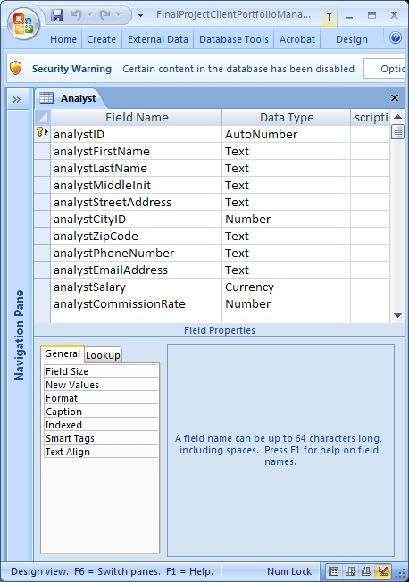

The City table is used to store each city that a client or analyst might live in.

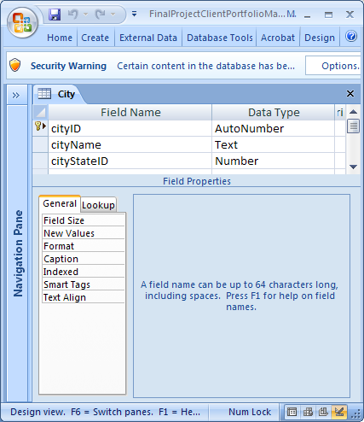
The Client table is used to store contact information for each client.

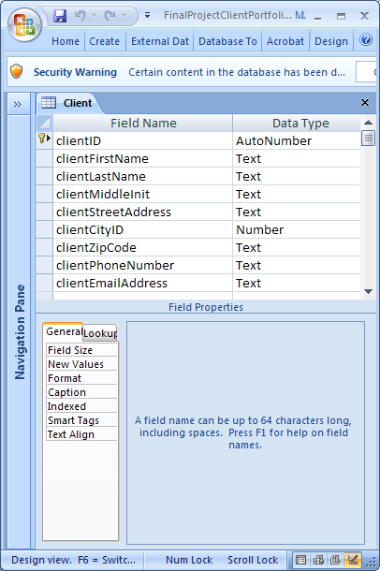
The ClientOwnerType table is used to store all possible types of ownership a client may have to a portfolio (Sole, Joint, etc.)

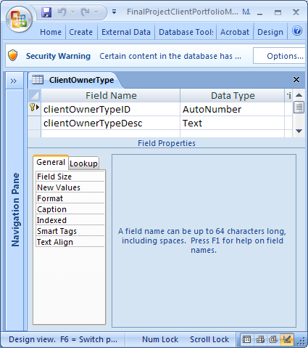
The Instrument table is used to store information about each investment instrument (its name, type, price, risk, transaction cost, expected return, etc.)

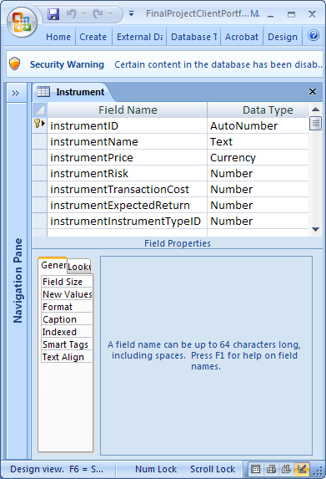
The InstrumentMarketSignal table is used to store the values of instrument signals for each instrument. It is a bridge table between Instrument and MarketSignal.

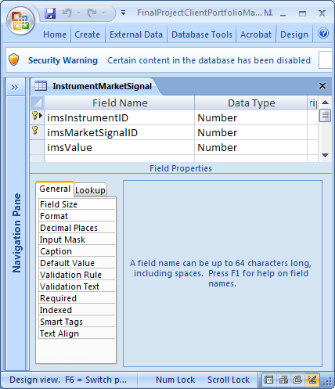

The InstrumentType table is used to define all the possible types of instruments (stocks, mutual funds, currencies, etc.)

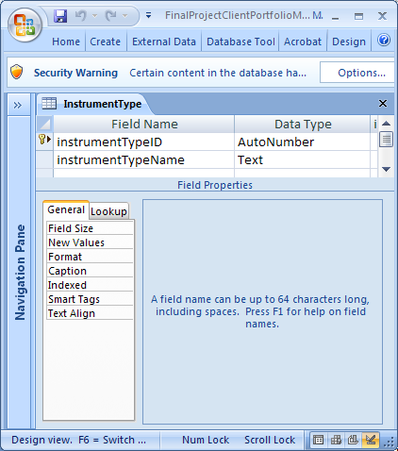
The MarketSignal table is used to define different investment measures to contribute to determining the return potential of each instrument.

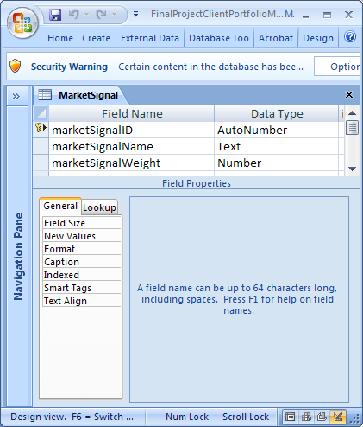
The Portfolio table is used to store information on each portfolio, including its name, present value, and which analyst manages the portfolio.

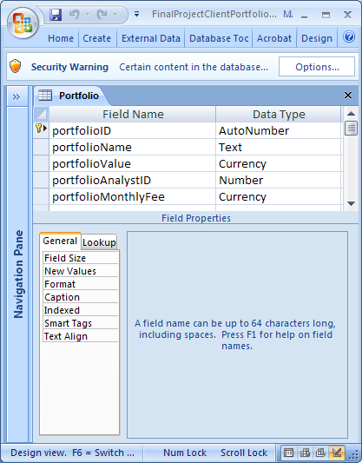
The PortfolioInstrument table is used to keep track of which instruments are held in each portfolio. It is a bridge table between the Portfolio table and the Instrument table.

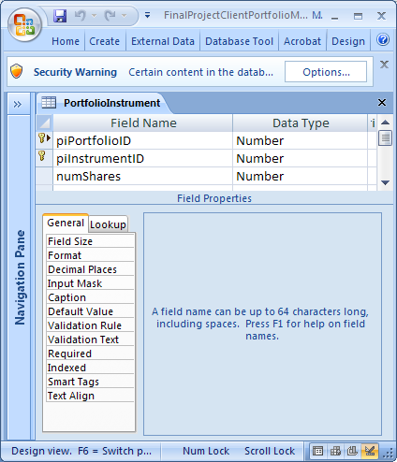

The PortfolioOwner table is used to keep track of which portfolios are owned by which clients, and which ownership type each client has for a portfolio. It is a bridge table between the Client, Portfolio, and ClientOwnerType tables.

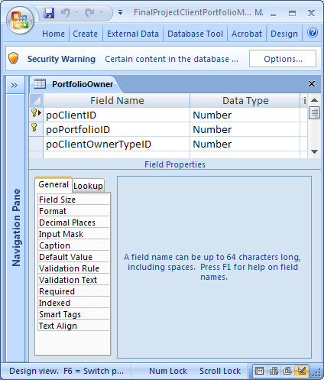
The State table contains a list of all the states that cities may belong to.

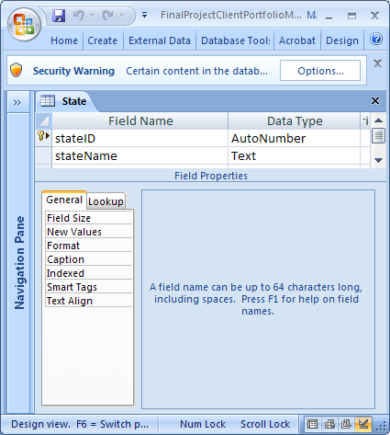
The Transaction table contains a record all transactions to buy and sell instruments for client portfolios. It is a bridge table between the Portfolio and Instrument tables.

